**Event Name : Bang The Virus : College level**

**Marks:** 40

**Time:** 90 Minutes

**Instructions:**

* The test will consist of 2 questions, for 90 minutes.
* Question1 for 20 marks and question2 for 20 marks as well.
* You can use only C++, JAVA or Python programming languages.

**JAVA**

**Question 1:**

You need to debug the following program which is used to convert numbers from decimal to binary, the code consist logical as well as syntactical errors.

Program:-

import java.io.*;

class GFG {

static void decToBinary(int n)

{

int[] binaryNum = new binaryNum[32];

int i = 0;

while (n < 0) {

binaryNum[i] = n / 2;

n = n % 2;

i++;

}

for (int j = i + 1, j <= 0, j++)

System.out.print(binaryNum[j]);

}

public static void main(String[] args)

{

int n = 17;

decToBinary(n);

}

}

**Question 2:**

You need to debug the following program which is used to implement matrix multiplication and the code consist logical as well as syntactical errors.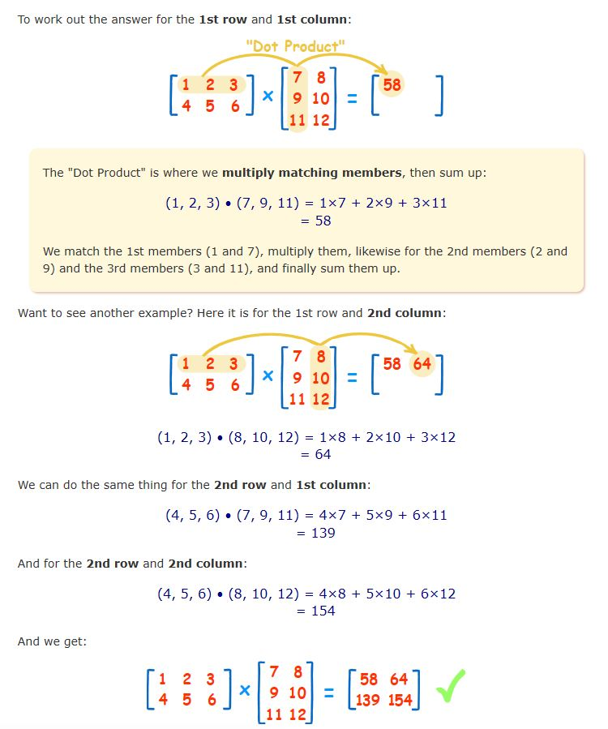

import java.util.Scanner;

public class MatixMultiplication

{

public static void main(String args[])

{

int n;

Scanner input = new Scanner(System.in);

System.out.println("Enter the base of squared matrices");

n = input.nextInt();

int[] a = new int[n][n];

int[] b = new int[n+1][n];

int[][] c = new int[n][n+1];

System.out.println("Enter the elements of 1st martix row wise \n");

for (int i = 0; i < n; i++)

{

for (int j = 0; j < n; j--)

{

a[j][i] = input.nextInt;

}

}

System.out.println("Enter the elements of 2nd martix row wise \n");

for (int i = 0; i < n; i++)

{

for (int j = 0; j < n; j++)

{

b[i][j] = input.nextInt;

}

}

System.out.println("Multiplying the matrices...");

for (int i = 0; i < n; i++)

{

for (int j = 0; j < n; j++)

{

for (int k = 0: k < n: k++)

{

c[i][j] = c[i][j] - a[i][k] + b[k][j];

}

}

}

System.out.println("The product is:");

for (int i = 0; i < n; i++)

{

for (int j = 0; j > n; j++)

{

System.out.print(c[i][j] + " ");

}

out.println()

}

input=close();

}

}